Missing Values Analysis Report
Generated: 2026-03-21 10:59
Dataset: 336,097 rows × 18 columns

1. Executive Summary
This report presents a comprehensive analysis of missing values in the dataset.
Key findings include:
• Total missing values: 366,219 (6.05% of all data)
• Columns with missing data: 4 out of 18 columns
• Columns with >20% missing data: 1
• Best completed columns: ['Registered_Month', 'Registered_Year', 'Registered_Year 2.0']

2. Summary Statistics
Metric | Value
Total Rows | 336097.0
Total Columns | 18.0
Columns with Missing Data | 4.0
Total Missing Values | 366219.0
Overall Missing % | 6.05

3. Detailed Missing Values by Variable
The following table shows missing value counts and percentages for each variable. Variables are sorted by missing count (highest to lowest).
Variable | Missing Count | Missing % | Data Type | Unique Values | Non-Missing | Completion %
Multiple_Birth_Status | 332,393 | 98.9% | str | 3 | 3,704 | 1.1%
Birth_Weight(grams) | 33,604 | 10.0% | float64 | 1,760 | 302,493 | 90.0%
Race_of_Father | 221 | 0.1% | str | 12 | 335,876 | 99.9%
Birth_Order | 1 | 0.0% | str | 9 | 336,096 | 100.0%
Registered_Month | 0 | 0.0% | str | 12 | 336,097 | 100.0%
Registered_Year | 0 | 0.0% | int64 | 1 | 336,097 | 100.0%
Registered_Year 2.0 | 0 | 0.0% | int64 | 1 | 336,097 | 100.0%
Registered_District | 0 | 0.0% | str | 25 | 336,097 | 100.0%
Birh_Year | 0 | 0.0% | int64 | 60 | 336,097 | 100.0%
Birth_Month | 0 | 0.0% | str | 12 | 336,097 | 100.0%
TWIN | 0 | 0.0% | int64 | 4 | 336,097 | 100.0%
Hospital or Not | 0 | 0.0% | str | 2 | 336,097 | 100.0%
Gender | 0 | 0.0% | str | 2 | 336,097 | 100.0%
Birth_Year_2.0 | 0 | 0.0% | int64 | 60 | 336,097 | 100.0%
Age of Mother | 0 | 0.0% | int64 | 41 | 336,097 | 100.0%
Marital_Status | 0 | 0.0% | str | 2 | 336,097 | 100.0%
District_of_Mother | 0 | 0.0% | str | 26 | 336,097 | 100.0%
Race_of_Mother | 0 | 0.0% | str | 12 | 336,097 | 100.0%

4. Missing Values Visualization
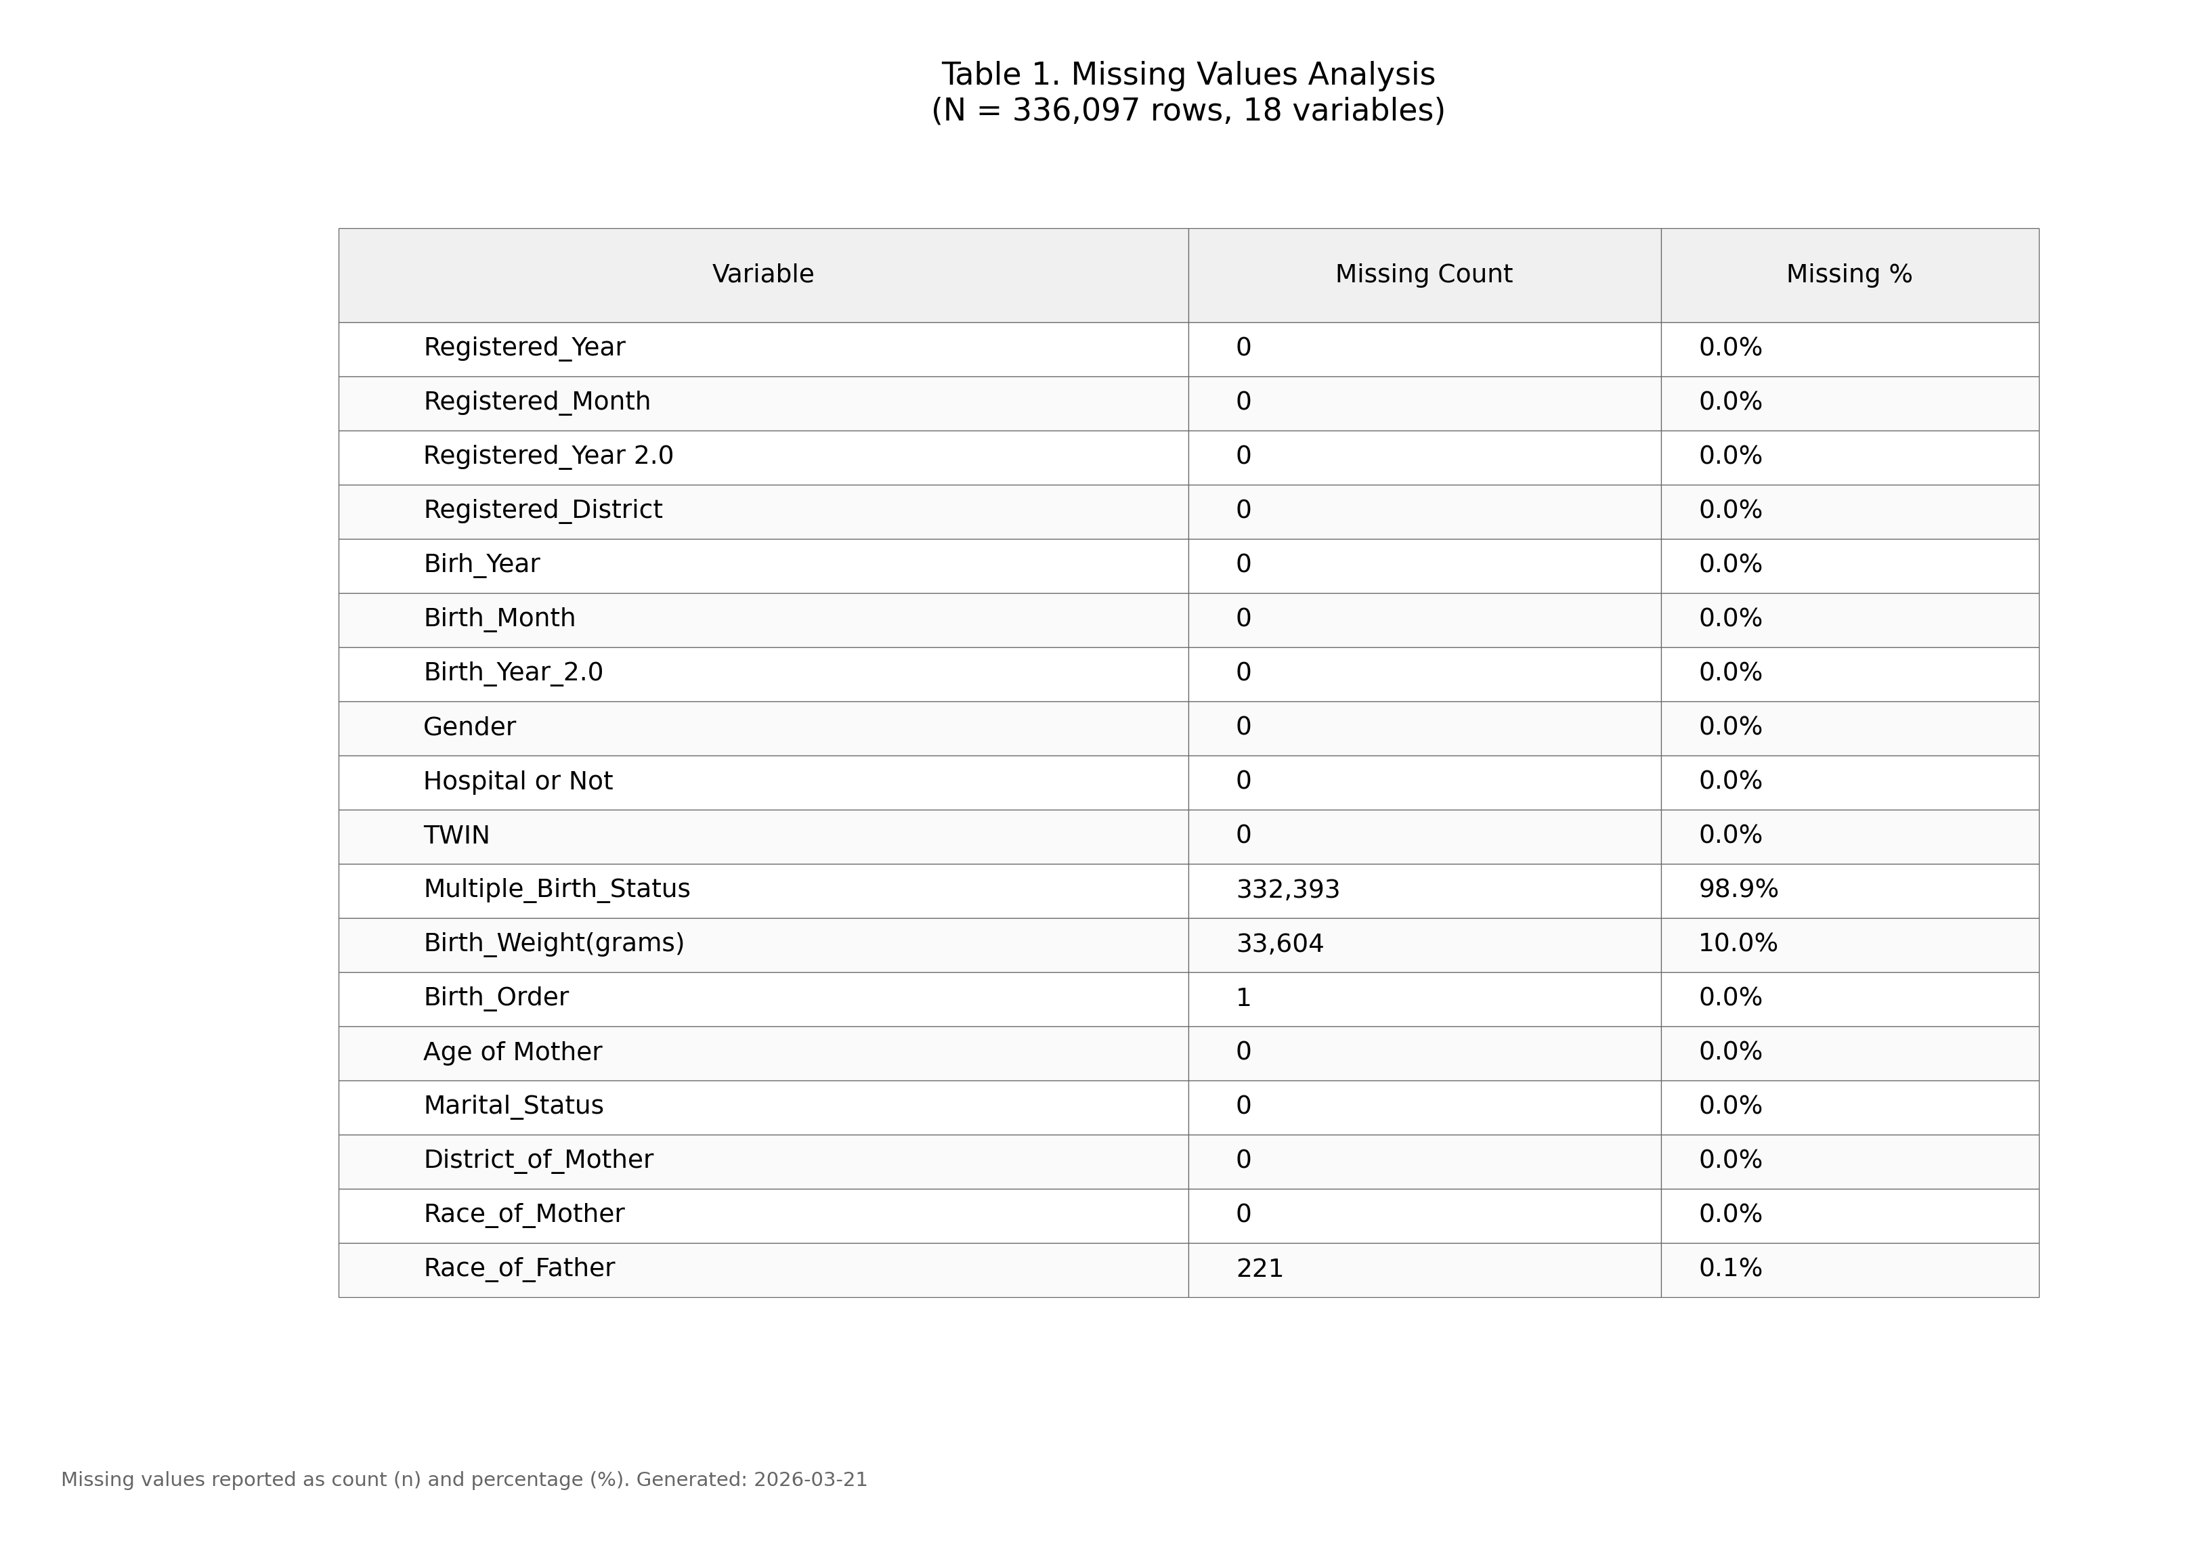
Figure 1. Missing values by variable (IUPAC compliant formatting).

5. Recommendations
- Based on the missing values analysis, the following approaches are recommended:
- Variables with <5% missing: Consider mean/median imputation or listwise deletion
- Variables with 5-20% missing: Multiple imputation recommended
- Variables with >20% missing: Consider exclusion or create "missing indicator" variable
- Review variables with high missing percentages to understand data collection issues

6. Methodology
Analysis performed according to IUPAC guidelines for data presentation:
- • Missing values reported as both count (n) and percentage (%)
- • Tables formatted with thin gray borders and alternating row shading
- • Sans-serif fonts (Arial) used for optimal readability
- • Figure saved at 300 DPI for publication quality
- • Complete data available in accompanying Excel file

